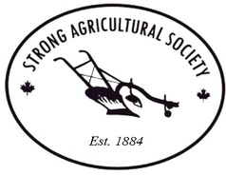
Strong Agricultural Society Fall Fair
14 Albert Street North, Sundridge
September 16, 2017

Join us as we build the largest Farmer's Market
of the season in the Almaguin Area

Vendor Agreement Form

This year we are having our Farmer's Market outside. We have some 10 x 10 tent spaces available – these spaces are limited and must be prepaid. Tables and chairs are the responsibility of the vendor. Hydro is not available. Gates open at 8:00 am.

Fair Date: Saturday, September 16, 2017

Vendor Fees:
Regular Space (No tent or supply your own) $ 20.00
Tented Space (10 x 10 tented space provided) $40.00

No. of Spaces required:
Regular _____ x $20 = _____
Tented _____ x $40 = _____

Name Of Business _______________________________________
Vendors’ Name:_________________________________________
Mailing Address:_________________________________________
City _________________________, Ontario
Postal Code__________ Telephone Number_____-_____-______
Email Address_____________________________________________
Signature:________________________________________________
Type of Merchandise:________________________________________
________________________________________________________
All products must be family friendly
Insurance Provider_____________________ Policy #_______________
(Home Insurance for those without commercial insurance)
Please fill in the form and send it, along with payment, to the

Strong Agricultural Society
c/o Harold O'Brien
PO Box 1012
Sundridge, Ontario P0A 1Z0

After payment has been received the Agricultural Society will email you 2 complimentary passes. Please be advised that each vendor/concession will receive 2 complimentary passes, all others must pay the gate fee. Please make all cheques or money orders out to the Strong Agricultural Society. We also accept e-transfers!!!

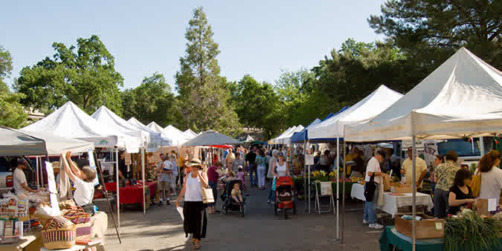
For more information or questions regarding being a vendor, please call Harold O'Brien @ 705-384-0711 or email at sasoctreasurer@gmail.com

